
Company
Logotype

Cone Beam Computed Tomography- Report



Porur Dental X-rays & CBCT

Patient Name : Mrs. Rajaseeli | Date of Report : 16.09.2024
Age/ Gender : 57 years/ Female | Region of Interest : CBCT Sectional Mandible
Referring doctor: Dr. M. Balamurali Sai | Indication : Implant assessment- 36
Clinical Notes: Nil
PATIENT INFORMATION

CBCT- Sectional Mandible provided
CBCT – IMAGE DETAILS

RADIOGRAPHIC INTERPRETATION

- Complete loss of crown and root structure in relation to 36, 38.
- The alveolar bone in relation to 36 is present with normal trabecular pattern.

IMPLANT ASSESSMENT

 | 36 region
Sub-Crestal (in mm) | 7
Mid- Crestal (in mm) | 8.8
Distance between alveolar ridge and the inferior alveolar nerve canal (in mm) | 14.86
Distance between alveolar ridge and the inferior border of mandible (in mm) | 25.33
Distance between distal portion of 45 and mesial portion of 47  (in mm) | 11.08

RADIOGRAPHIC IMPRESSION

- Partially edentulous region: 36.

Kindly correlate with clinical findings


IMAGES FOR REFERENCE

RECONSTRUCTED PANORAMIC VIEW
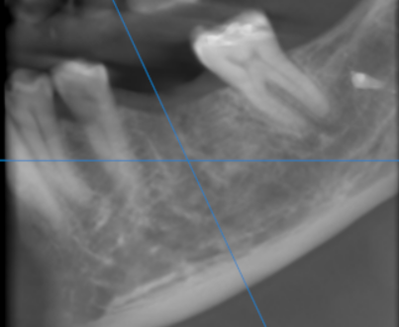

3-DIMENSIONAL VIEW
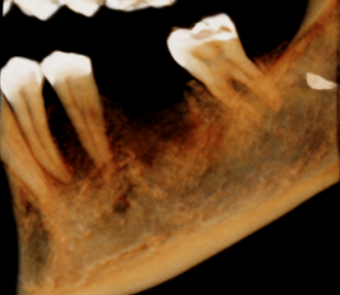

CROSS SECTIONAL VIEW

36 region | 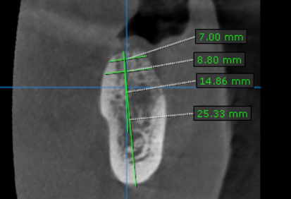

**** End of report ****

